PF LAB:7

24K-O514

MUHAMMAD

UMER FAROOQ

# QUESTION 1:

Write a C Program that takes an user input array and prints the sum of its elements.

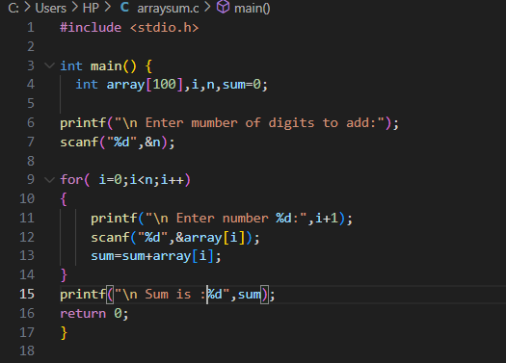

OUTPUT:

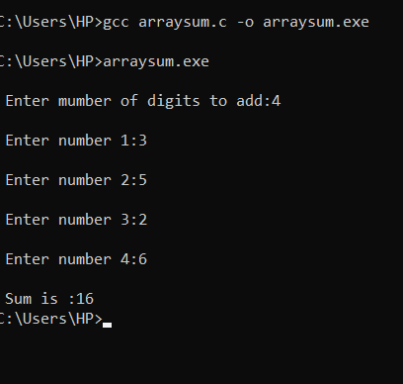

## QUESTION 2:

Write a program in C to read n number of values in an array and display it in reverse order.

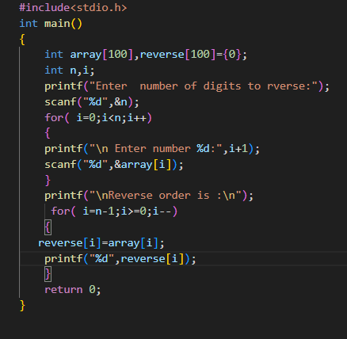

OUTPUT:

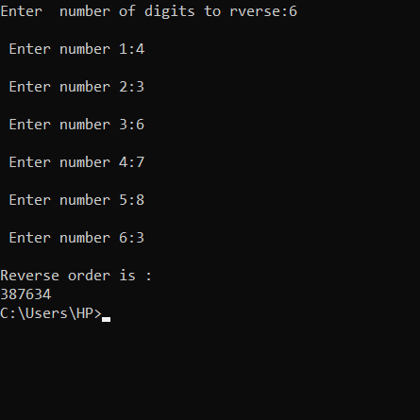

### QUESTION 3:

Write a C Program to find the minimum and maximum number in an array.

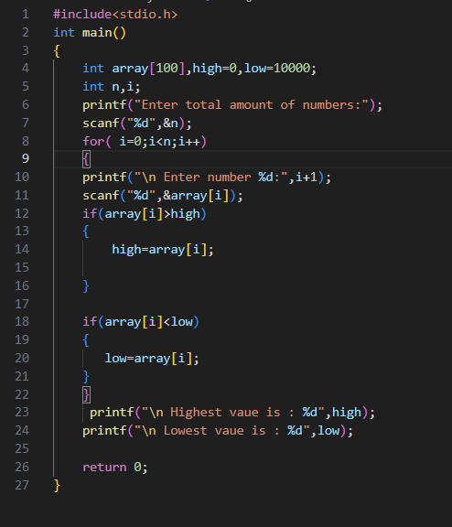

OUTPUT:

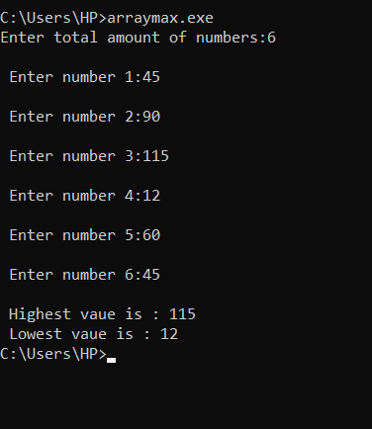

#### QUESTION 4:

Given an array arr[] of size N which contains elements from 0 to N-1, you need to find all the elements occurring more than once in the given array.

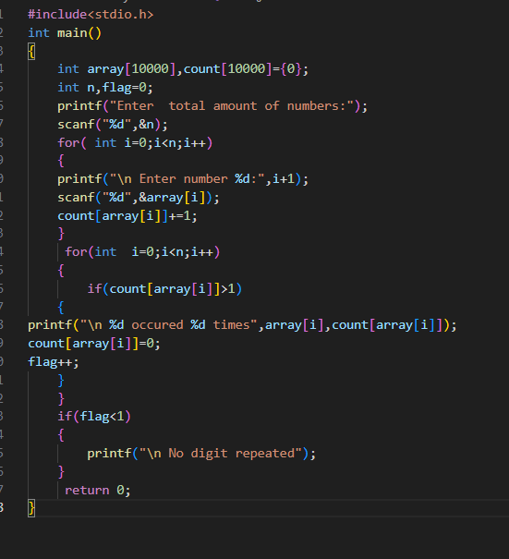

OUTPUT:

